Jira progress 29-12-2025
Dashboard in Jira
A Jira Dashboard is a customizable screen that shows important project and team information at a glance using visual widgets called gadgets.
What is a Jira Dashboard?
A dashboard is the first page you see after logging in to Jira.
It helps you track progress, workload, and issues without opening each project.
Why Dashboards are Used
- Track project status
- Monitor team workload
- View open, closed, or overdue issues
- Support daily standups & reviews
- Help managers make quick decisions
Main Components of a Dashboard
1.Gadgets
Small visual blocks that show data.
Common gadgets:
- Filter Results – list of issues from a JQL filter
- Pie Chart – issues by status, priority, assignee
- Sprint Burndown Chart – sprint progress
Created vs Resolved Chart
- Assigned to Me
- Average Age of Issues

2.Filters
- Dashboards use JQL filters to fetch data.
3.Layout
- 1-column, 2-column, or 3-column layout
- Gadgets can be dragged and rearranged

Types of Dashboards
- Personal Dashboard – for individual users
- Team Dashboard – shared with team
- Management Dashboard – high-level reports
- Scrum Dashboard – sprint-focused
- Kanban Dashboard – flow & WIP tracking

Who Uses Jira Dashboards?
Role | Usage
Developer | My tasks, bugs
Tester | Open defects
Scrum Master | Sprint progress
Manager | Project health
Product Owner | Backlog & delivery

What are Cross Teams?
Cross teams means multiple teams working together on a single product, program, or goal.
Each team has its own responsibilities, but their work is interdependent.
Example:
Frontend Team + Backend Team + QA Team → One product release
Why Cross Teams Are Needed
- Large or complex projects
- Faster delivery
- Specialized skills
- Parallel work
- Shared ownership of outcomes
How Cross Teams Work in Jira
1. Team Structure
Each team may have:
- Its own board (Scrum / Kanban)
- Separate sprints
- Separate workflows
But they share:
- Epics
- Releases (Versions)
- Goals
2. Issue Organization
To distinguish teams:
- Components (Frontend, Backend, QA)
- Labels (team-a, team-b)
- Custom Team field
3. Dependencies Between Teams
Handled using:
- Linked Issues
  - blocks
  - is blocked by
  - depends on
This shows how one team’s work affects another.
How Cross Teams Are Managed
Using Jira Features
- Epics → track work across teams
- Roadmaps / Advanced Roadmaps → long-term planning
- Versions → release tracking
- Backlog → shared priorities
- Dashboards → monitoring & visibility
Monitoring Cross Teams with Dashboards
Common Dashboard Gadgets:
- Filter Results → all teams’ issues
- Pie Chart → work by team/component
- Created vs Resolved → delivery rate
- Version Progress → release readiness
- Linked Issues → dependency tracking
Roles in Cross-Team Setup
Role | Responsibility
Product Owner | Priority alignment
Scrum Master | Dependency removal
Team Leads | Team delivery
Program Manager | Cross-team coordination

What are Screens?
Screens control which fields appear when:
- Creating an issue
- Editing an issue
- Viewing an issue
Screens do not control behavior, only visibility.
Screen Types
- Create Screen
- Edit Screen
- View Screen
These are combined into a Screen Scheme.
Workflows (How issues move)
What is a Workflow?
A workflow defines the lifecycle of an issue.
Example:
To Do → In Progress → In Review → Done
Workflow Components
- Statuses (To Do, Done)
- Transitions (movement between statuses)
- Conditions (who can transition)
- Validators (what must be filled)
- Post Functions (what happens after transition)

Why Workflows Matter
- Enforce process
- Control approvals
- Ensure data quality
- Track progress
How Fields, Screens & Workflows Work Together
Example: Bug Fix Process
- Fields: Severity, Environment
- Screen: Show Severity only for Bugs
- Workflow:
  - Cannot move to Done unless Resolution is set
  - QA approval required

Real-Time Mapping Table
Element | Purpose | Example
Field | Stores data | Priority
Screen | Displays fields | Bug Create Screen
Workflow | Controls movement | To Do → Done
Sample dashboard
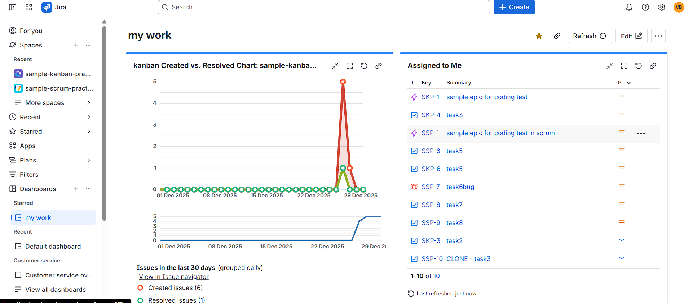

Jira Roles and Responsibilities
1. Product Owner (PO)
- Can Create / Manage: Backlog, Epics, User Stories, Releases, Priorities, Acceptance Criteria.
- Does Not Typically: Manage technical sprint details or change workflows.
- Main Responsibility: Defining what should be built and the order of importance.
2. Scrum Master
- Can Create / Manage: Sprints (Start/End), Moving issues between sprints, Sprint reports, Removing blockers.
- Does Not Typically: Decide business priorities or create releases.
- Main Responsibility: Ensuring the team follows Agile practices and removing obstacles.
3. Developer / Team Member
- Can Create / Manage: Tasks, Sub-tasks, Bugs, Status updates, Work logs.
- Does Not Typically: Create sprints, create releases, or change backlog priority.
- Main Responsibility: Building and delivering the actual work.
4. QA / Tester
- Can Create / Manage: Bugs, Bug status updates, Test results, Reopening issues.
- Does Not Typically: Create stories, epics, or sprints.
- Main Responsibility: Ensuring quality and verifying fixes.
5. Project Manager / Delivery Manager
- Can Create / Manage: Releases, Dashboards, Reports, Cross-team tracking, Dependencies.
- Main Responsibility: Tracking overall delivery and stakeholder communication.
6. Jira Admin
- Can Create / Manage: Workflows, Custom fields, Screens, Permissions, Issue types, Project settings.
- Main Responsibility: System configuration and tool maintenance.

Role vs Item
Item | PO | Scrum Master | Dev | QA | PM | Admin
Backlog | Yes | No | No | No | No | No
Epic | Yes | No | No | No | No | No
Story | Yes | No | No | No | No | No
Task | No | No | Yes | Yes | No | No
Bug | No | No | Yes | Yes | No | No
Sprint | No | Yes | No | No | No | No
Release | Yes | No | No | No | Yes | No
Workflow | No | No | No | No | No | Yes

